**Start with mongo command:**

C:\Users\Karthick Raja>mongo

**Hints:**

*Collection means tables in mongo

*document-{whatever inside consider be a one document}

*colums- document contains key pair

*rows- document contains value pair

*this mongodb takes one db contains n number of collection as well a single collection contains n number of documents.

*mongodb allows 100 levels of nesting

*it works with BSON-binary serialization format.

**1.Create Database(name with school):**



**2.To show Database:**

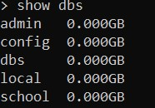

**3.create collection(Student) in school database with insertone:** 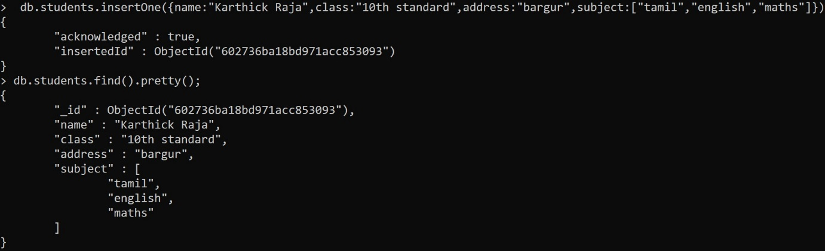

**4.create collection in school database with insertmany:**

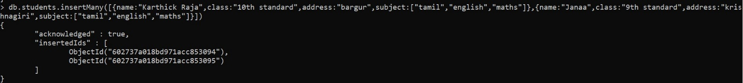

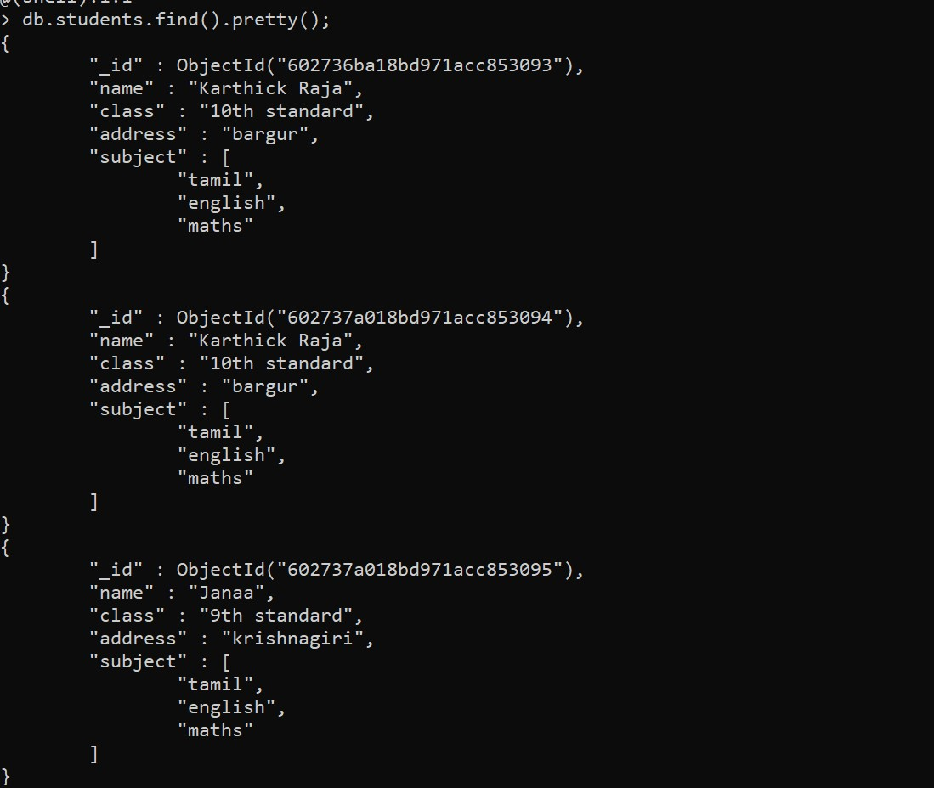**5.updateone in student collection:**

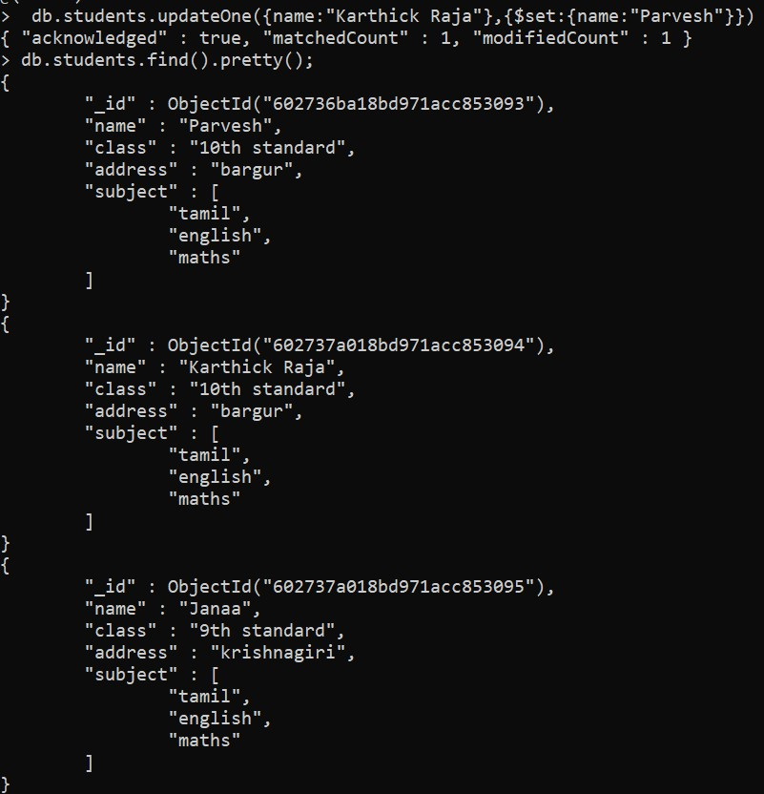

**6.Deleteone in students collection:**

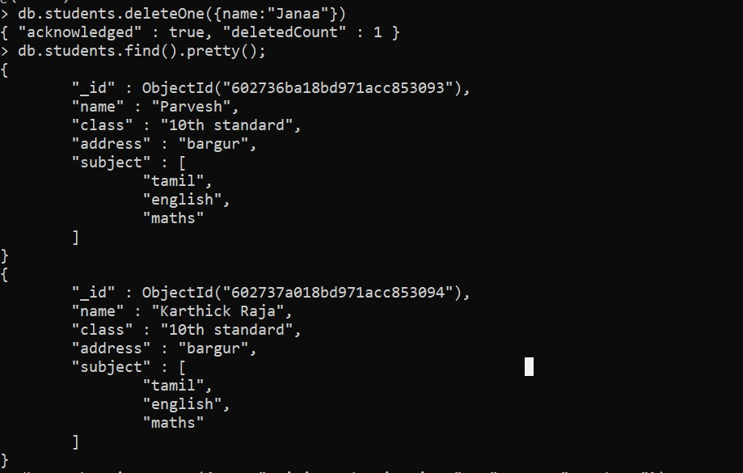

**II.join 2 collection in same db(school db) :**

**7.create another collection(Teacher):**

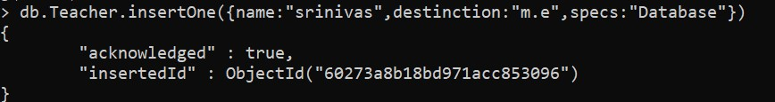

**8.show the total collections(2) avail in school db:**

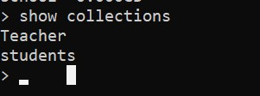

**9.merge 2nd collection(Teacher) with 1st collection(Student) with id:**

